Date | 6 feb 2026
Team ID | LTVIP2026TMIDS82987
Project Name | Strategic Product Placement Analysis: Unveiling Sales Impact with Tableau Visualization
Maximum Marks | 6 Marks
Data Visuals(Data Preprocessing,Bussiness Questions)

Part 1: Data Preprocessing Steps
This section explains how I prepared the raw CSV data for use within the Tableau environment.
1. Data Connection & Metadata Review
Step: I imported the Product Positioning.csv into Tableau.
Action: I reviewed the 1,000 rows to ensure no data was missing. I confirmed that numerical fields like Price, Competitor's Price, and Sales Volume were correctly identified as Measures.
2. Data Type Optimization
Step: Fixing the Product ID field.
Action: By default, Tableau treated the Product ID as a number (Measure). Since we do not calculate the average or sum of IDs, I converted this field to a Dimension (String) to use it correctly as a unique identifier for products in my scatter plots.
3. Categorical Organization
Step: Organizing store attributes.
Action: I ensured that categorical fields such as Product Position (Aisle, End-cap, Front of Store), Foot Traffic (Low, Medium, High), and Promotion (Yes, No) were sorted in a logical order to make the final visualizations easier to read.
4. Creating a Data Extract
Step: Preparing for Tableau Public.
Action: I changed the connection from 'Live' to 'Extract'. This was necessary to package the data with the workbook so it could be published online and integrated into the Flask web interface.

Part 2: Business Questions with Visualizations
These questions explain the logic behind each activity I created in Tableau.

Q1: Which product categories are the top performers in terms of volume?
Visualization: Bar Chart (Avg Sales Volume vs. Product Category).
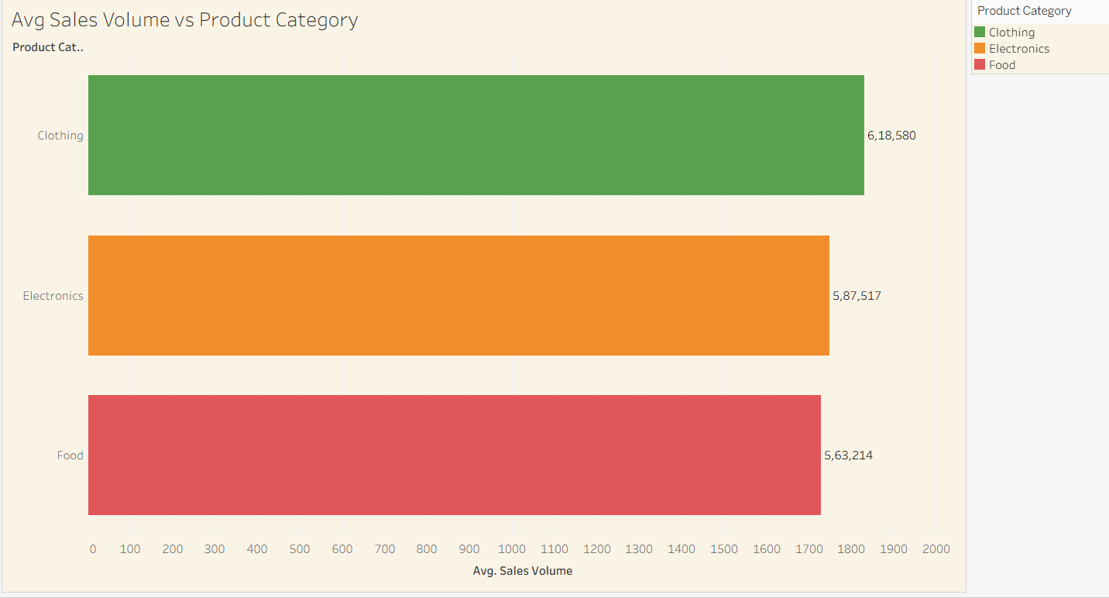
I used the Average of Sales Volume to see the typical performance of each category. This helps the business see that Clothing and Electronics are the main drivers of units sold.

Q2: How does our pricing compare to the competition?
Visualization: Scatter Plot (Price vs. Competitor's Price).
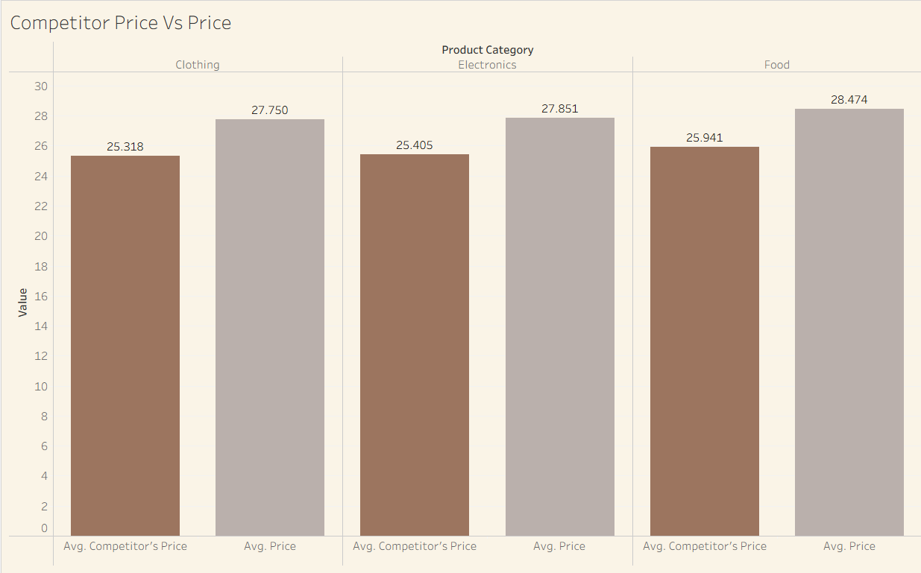
I plotted our price against the competitor's price for every Product ID. This visual shows a strong correlation, meaning we are keeping our prices very close to the market average to stay competitive.

Q3: Does the specific shelf position affect sales differently for each category?
Visualization: Grouped Bar Chart (Avg Sales Volume by Category & Position).
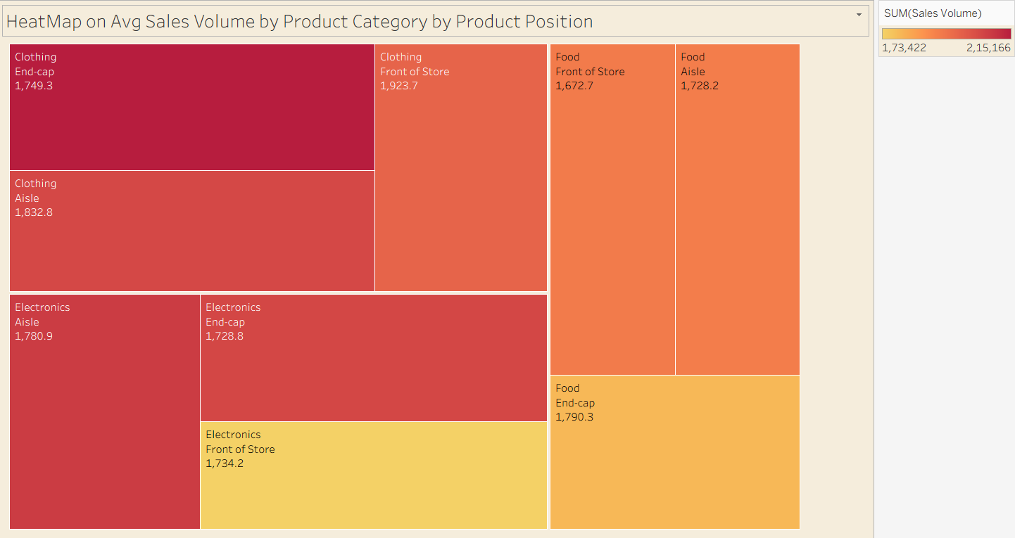
By placing Category and Position side-by-side, I could see that some positions (like Front of Store) work better for certain categories than others, which is vital for store layout planning.

Q4: Which customer group should we target for our next marketing campaign?
Visualization: Bar Chart (Consumer Demographics vs. Sales Volume).
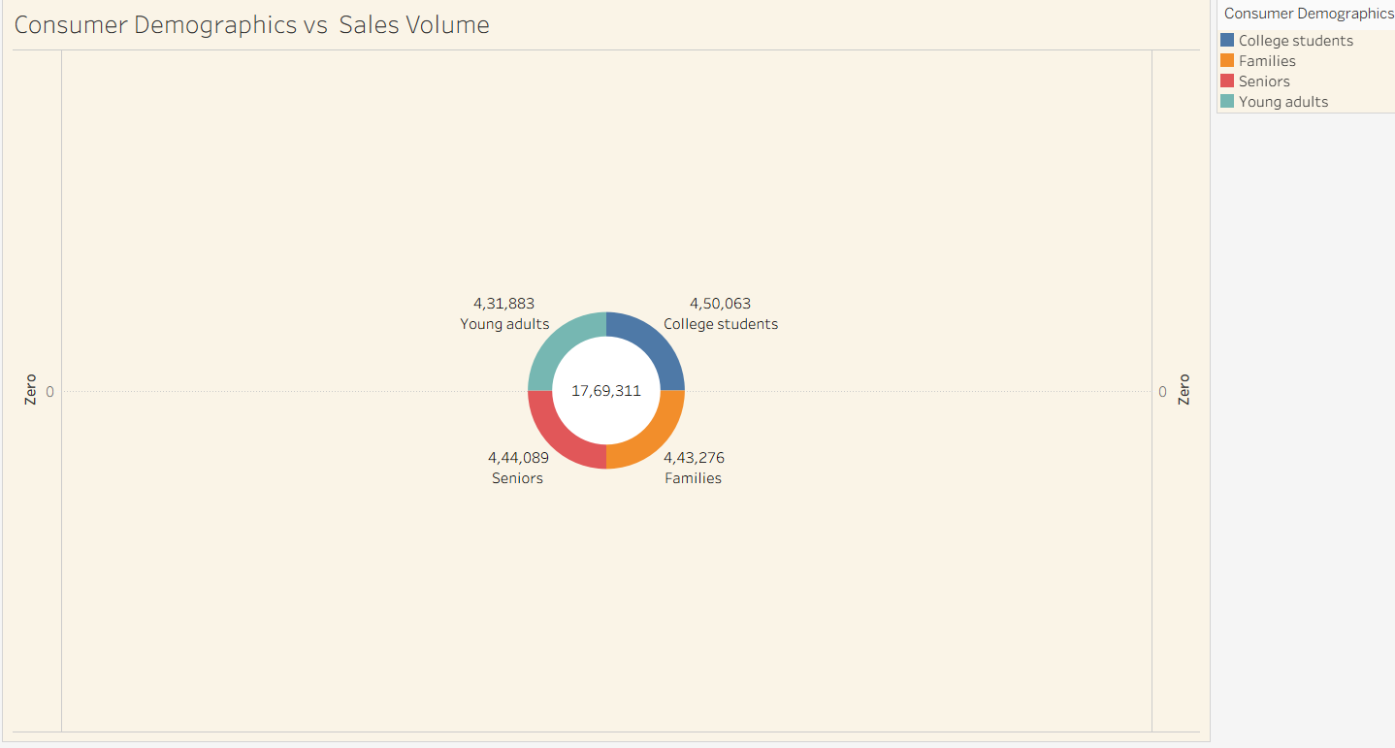
I analyzed total sales across Seniors, Families, and Students. This shows exactly which demographic group is actually spending the most at our stores.

Q5: Is there a link between Foot Traffic and actual sales?
Visualization: Bar Chart (Foot Traffic vs. Avg Sales Volume).
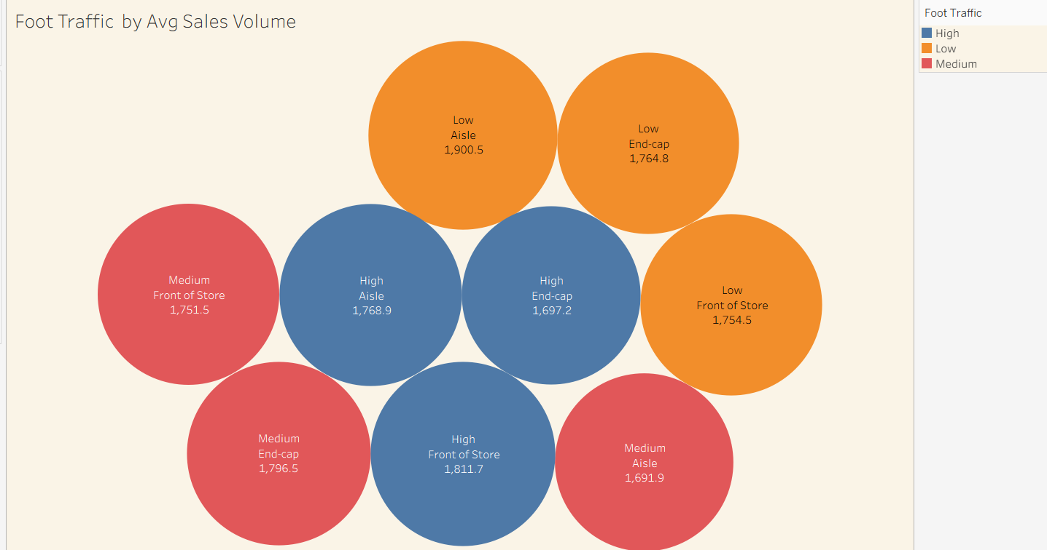
I wanted to see if more "eyes" on a product always leads to more sales. This chart reveals if High Traffic areas are actually converting visitors into buyers.

Q6: How do promotions and seasons interact to change sales?
Visualization: Dual Axis or Color-coded Bar Charts.
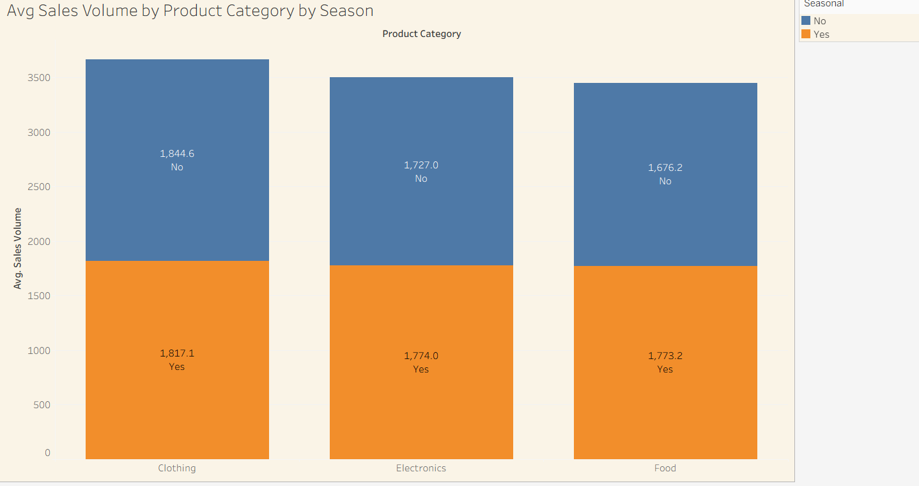
I used the Promotion and Seasonal columns as "Colors" in my charts. This makes it instantly obvious if a "Yes" (on promotion) bar is taller than a "No" bar, proving whether our discounts are working.

